Vilom Chronicles

Game Design - Universiteit Utrecht (2016)

*Concept by MOJO JOJO studios*

*Iwan Boksebeld(5719100), Cas Laugs (4140613), Sjors Gielen(5558956), Jelle Steinmetz(5596424), Frans Zoetmulder(5729378)*

## 

## 

## Introduction

Vilom Chronicles is a unique take on the traditional 2D platformer genre. The player starts the game as an evil necromancer (for more backstory, see the Story chapter) that has the desire to corrupt and conquer the entire game-world with it’s magic. This differs from almost every other 2D platformer because the player almost always plays the good guy. However, the main twist of the game, is that the player, once he or she has completed the necromancers side of the game and conquered/corrupted the entire gameworld, suddenly has to play as the good guy and fight it’s way back through all of the levels already completed by the necromancer. The difference is that all of the levels are corrupted (evil) and totally different based on how the necromancer acted, while still feeling like the level you visited before as the necromancer.

Vilom Chronicles focuses on giving the player the experience of:

*Action-packed skill-testingly challenging but fair platforming*

How this is achieved in Vilom Chronicles is described in full detail in the Gameplay section.

## Story

Tanis (the good character) makes Vairl(the evil character) leave in frustration. Vairl finds a staff of immense evil power. Vairl corrupts the land and captures the princess. Tanis then moves through the same lands as Vairl did to rescue the princess. Vairl and Tanis have both their arc’s be played.

## Gameplay

The gameplay is the most important part of Vilom Chronicles because there is a very thin line between very hard but fair gameplay and frustratingly unfair gameplay. This is also the part where Vilom Chronicles shines the most because the player should experience large amounts of satisfaction when achieving even small objectives like outplaying a single new enemy or completing a platforming section.

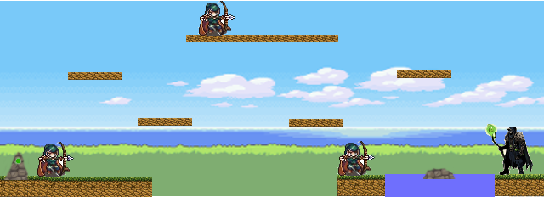

A major point of the gameplay is the fact that you play both roles but the player is not aware of this at the start of the game. The villain and the hero. The player starts with the villain playthrough, where one of the primary objectives is to corrupt the land to gain more power and conquer the entire world of Mosredna. To finish of the Villain playthrough Vairl captures the princess and returns to his own lair. The goal of the necromancer is to corrupt each level. The knight playthrough goes through the stages that the necromancer completed from end to start. His goal is to kill the necromancer and save the princess. The necromancer travels from right to left while the knight travels from left to right, symbolizing the good guy path and the evil guy path. The level of corruption and what is corrupted is based on choices/actions (Checkpoints, killing enemies, destroying the environment etc.) that the necromancer takes and the completion percentage. The level of corruption affects how the stage will be for the knight playthrough. A higher corruption level results in stronger enemies, different platforming and visual representation. For example, in a stage where the player had to cross a lake by jumping from rock to rock as the necromancer, in the corrupted version the lake is now lava or poison, the rocks disintegrate when the player steps on them and there are monsters that jump up from the lava/poison. This way, multiple playthroughs are possible.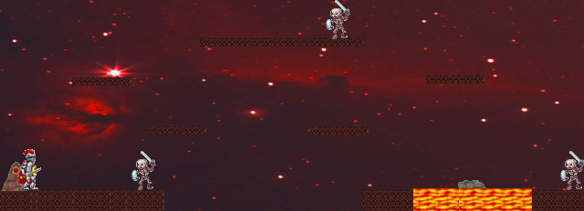

Aside from the platforming and some minor puzzles, the general combat is that the player has to learn and react to the behavior of an enemy before it can easily kill it. Enemies are not dull cannon fodder in this game but are each a learnable opponent with characteristics that the player has to master. Each enemy has certain audio and/or visual clues about that it is going to do and the player has to find out how to react to that. For example, a skeleton-archer has two attacks. A stream of horizontal arrows and a spread-arrow attack. The knight can block the spread-attack and can jump over the stream-attack. The player has to identify which attack the archer is going to use and block or jump accordingly to get in close and kill the enemy. Because the player has to react fast and smart, the necromancer and knight both are very responsive and precise to control in their own ways.

As the necromancer, the player is able to use certain magical abilities which makes it easier to play than the knight. For example, the necromancer has ranged magic spells, the ability to hover for a while or a dash teleport etc. However, the knight only has a shield and it’s melee weapons and moves slower/different due to his heavy armor. This means that the knight has to get close and personal with the enemies while the necromancer can pick them off from a distance. This way, the player will have it generally easier on the first half of the game than on the latter half, gradually increasing the difficulty as the game progresses and offering two type of play styles. (To complement the fact that the knight is harder to play, all of the levels will be designed in such a way that the difficulty scales at a fair pace).

## Graphics & Sound Necromancer and Knight.png

As a 2D platformer, detailed (high-end 16-bit) sprite-based graphics suits the gameplay and theme. Everything, so the levels, characters, monsters and other assets are made in a lightly cartoony and fantasy style. The characters and enemies are animated in such a way that they convey their actions and states clearly.

For the sound of Vilom Chronicles we choose stereotypical sound effects. Audio-cue’s should be easily recognizable as they are an important part of the reacting to patterns-gameplay. For example, the charging of an attack or different types of grunts by the same enemy (which resemble different sort of attacks) should be clearly hearable and distinguishable. For the music, fast paced music with a medieval/evil bite fits the game perfectly as the game keeps a constant high pace (the music will keep the player ‘pumped’). Something slightly below Drum & Bass BPM is optimal. For boss stages, the BPM and intensity can be increased further.